Under-threat hospital achieving results no other health service can offer, former boss says
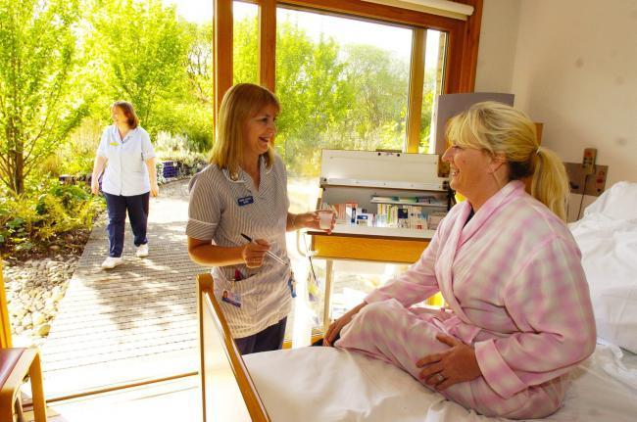
A hospital facing the loss of its overnight ward is achieving results that no other health service can boast, according to its former head.
NHS Greater Glasgow and Clyde is proposing to shut all seven inpatient beds at the Centre for Integrative Care (CIC) the only hospital of its kind in the UK.
The proposals are part of a raft of cuts aimed at saving NHS Greater Glasgow and Clyde around £70million.
Dr David Reilly, the hospital's former Clinical Director, led the campaign in 2004 when the ward was first threatened, and the beds already cut from 15.

The Scottish Government later recommended not only retaining the beds but expressed hope that the 'person-centred' approach used at the CIC could be more widely spread across the health service.
NHS Greater Glasgow and Clyde itself acknowledged that the service offered, " a valid and important model of care for patients whose needs were not being met by conventional treatment."
However, a public consultation has been launched on plans to axe the service with a decision expected at a meeting of the board in December.
Dr Reilly, who left the hospital in May, has called for more funding rather than less for 'person-centred' health services like the CIC because of the potential to treat, "the long-term conditions epidemic.

He cites a study involving 70 patients where four out of ten who were "pre-diabetic" were symptomless after undergoing a programme aimed at helping people improve their own health.
Patients suffering from chronic pain caused by conditions such as Multiple Sclerosis, arthritis, ME or cancer are offered a range of therapies including mindfulness, counselling, physiotherapy, therapeutic massage, acupuncture and homeopathy as well as dietary advice.
However, Dr Reilly, who is a fellow of the Royal College of Physicians, says the main ethos of the centre is to teach people how to manage their own condition.
He said: "The centre represents what should be the first bud, of a different way of tackling chronic conditions rather than seeing, diagnosing and prescribing.

"We have to move beyond the drug model.
"We have demonstrated transformative reactions in people. Almost half of the people we saw were showing pre-diabetic tendencies.
"In one year, there were sustained improvements in this. Four out of ten of the patients we saw who were pre-diabetic were no longer pre-diabetic.
"We are already spending 10% of our budget on diabetes.
"People only have to be admitted because they can't find that service elsewhere.
"For me, the debate is what form of care do we want? Do we want to develop models of deeply integrative approaches, to start turning around the desperate people with multiple long-term conditions.
"We all know that primary care is stretched beyond its limit.
"Over the last few years, people are beginning to head in this direction but the centre is well ahead.
"Many people with cancer seek help at the CIC to complement their chemotherapy."
The first homeopathic hospital in Glasgow opened in 1914 at 5 Lyndoch Crescent. It was later relocated to 1000 Great Western Road in 1931 and amalgamated with the children's homeopathic hospital.
The children's hospital closed in the 1970s and in January 1999 it moved to new purpose-built hospital premises in the grounds of Gartnavel General Hospital, less than half a mile away.
The inpatient unit opened in 1999 with 15 beds operating seven days a week. The service has been gradually reduced to seven beds operating five days a week alongside outpatient clinics.

A number of Scottish health boards, including NHS Lanarkshire, have stopped referring patients to the CIC. Dr Reilly says the debate over the future of the service has been unfairly focussed on homeopathy, a small part of the services offered and an "easy target" for justifying cuts.
Dr Reilly said: "The centre has been drawn into a narrow inappropriate dialogue about homeopathy.
"There was a report done which showed there had been four big waves of public health within the last 300 years.
"These waves were now showing diminishing returns in the face of the long-term conditions and we needed a fifth wave.
"The conversation started to grow around phrases like person-centred care - and I can genuinely say that a lot of those phrases were given birth to at the centre for integrative care.

"The CIC is not about a 'list of therapies.' It's about a fifth way of working.
"In the 1980s there was a rise in the use of complementary therapies, but people use them in the same way as orthodox therapies. They hope it's going to be a 'fit it.'
"I led the campaign back in 2004 when the inpatient unit was first under threat, The conclusions were that not only were they going to continue the beds but that there was a hope that the ethos could be more widely spread through the health service.
"What to me would make more sense would be to would re-expand the beds to 15 and to join up with the chronic pain service at Gartnavel.

"That service could be enriched by the expertise that has been built up in the unit.
"Everyone knows that care is feeling fragmented. There is too much prescribing.
"We have to move beyond the idea of a 'fix it' because there is no conventional therapy or complementary therapy that is going to fix the epidemics like diabetes or obesity.
"People wouldn't dream of treating their dogs the way they treat themselves. They wouldn't stress their pets out the way they stress themselves out.
"They wouldn't feed it the junk food that they feed themselves.
"We are way beyond going to the doctor for a prescription. It's about activating a big shift in self-care."
To contribute to the consultation go to at www.nhsggc.org.uk/inform-engage-consult/CIC or email Public.Involvement@ggc.scot.nhs.uk

